Canon Océ JetStream Dual 3000
The Canon Océ JetStream Dual 3000 is a continuous feed production inkjet device announced in 2011. The device is targeted at production printing of Books – Monochrome, Direct Marketing – Self Mailers, Newspapers, Traditional Transaction Print, Transitional Mail. It has a top speed of 2860 and uses aqueous dye ink.
Product Family: JetStream Dual Series
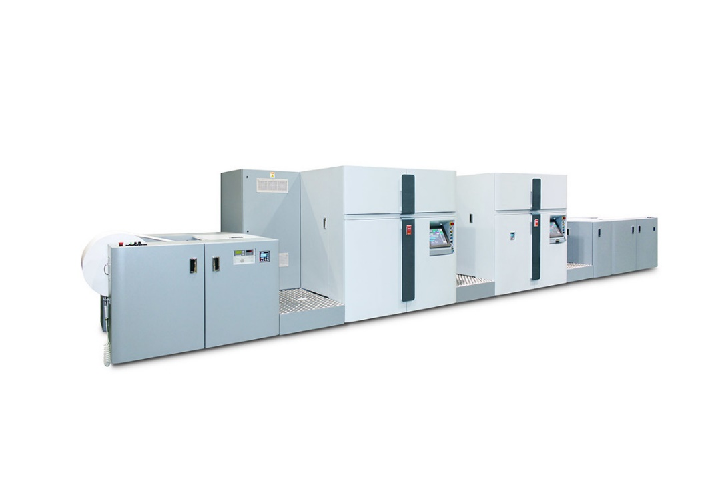

Productivity
Speed Reported | 85,800 sheets/hr.
FPM Reported | 656
IPM Reported | 2860
Duty Cycle Reported | 50-80 million letter impressions per month

Digital Front End
Controller Options | SRA MP, high-performance dual core blade processors
Print Streams | IPDS, PCL

Imaging System
Ink Type | Aqueous Dye
Ink Description | Water-based dye, MICR, Security Inks, InkSafe technology
Ink Options | CMYK + MICR
Bonding Agent | Not Reported
Primer/Precoat | Not Reported
Drying Methods | heated drum
Head Technology | Piezoelectric Drop-on-Demand
Head Manufacturer | Kyocera
Heads Per Engine | 80
Colors | 5
Droplet Size | 7-12 (variable)
Gray levels | 4
Resolutions | 600x600 1200dpi perceived

Paper & Media
Paper Feed | Roll
Paper Output | Roll
Minimum Web Width | 6.5 in / 165 mm
Maximum Web Width | 20.5 in / 520 mm
Maximum Print Width Simplex | 20.3 in / 516 mm
Maximum Print Width Duplex | 20.3 in / 516 mm
Minimum Thickness | 64 GSM
Maximum Thickness | 157 GSM
Paper Types | Recycled, wood free, pigmented, inkjet treated, inkjet coated
Specialty Media | Pre-printed, pre-punched, pre-perforated

Market Segments
Manufacturer Segment Notes | Transaction, Trans-promo, direct mail, news paper and book/magazine printing
Applications Segments | Books – Monochrome  Direct Marketing – Self Mailers  Newspapers  Traditional Transaction Print  Transitional Mail

Configuration
Layout Configuration | I
Print Engines | 2
Print Sides | Duplex
Power Consumption | 69 kW
Footprint: | 355 in x 115 in x 75 in / 9017 mm x 2921 mm x 1905mm (per tower)
Noise: | < 72 dB
Weight: | 26015 lb / 11800 kg
Humidity Range: | Optimal range 40–60% RH, limited range 30–80% RH
Temperature Range: | Optimal range 68–79°F / 20–26°C, Limited range 61–84°F / 16–28°C

