Canon Océ JetStream 5500 Wide
The Canon Océ JetStream 5500 Wide is a continuous feed production inkjet device announced in 2012. The device is targeted at production printing of Books – Monochrome, Direct Marketing – Self Mailers, Traditional Transaction Print. It has a top speed of 5452 and uses aqueous dye ink.

Product Family: JetStream Wide Series Productivity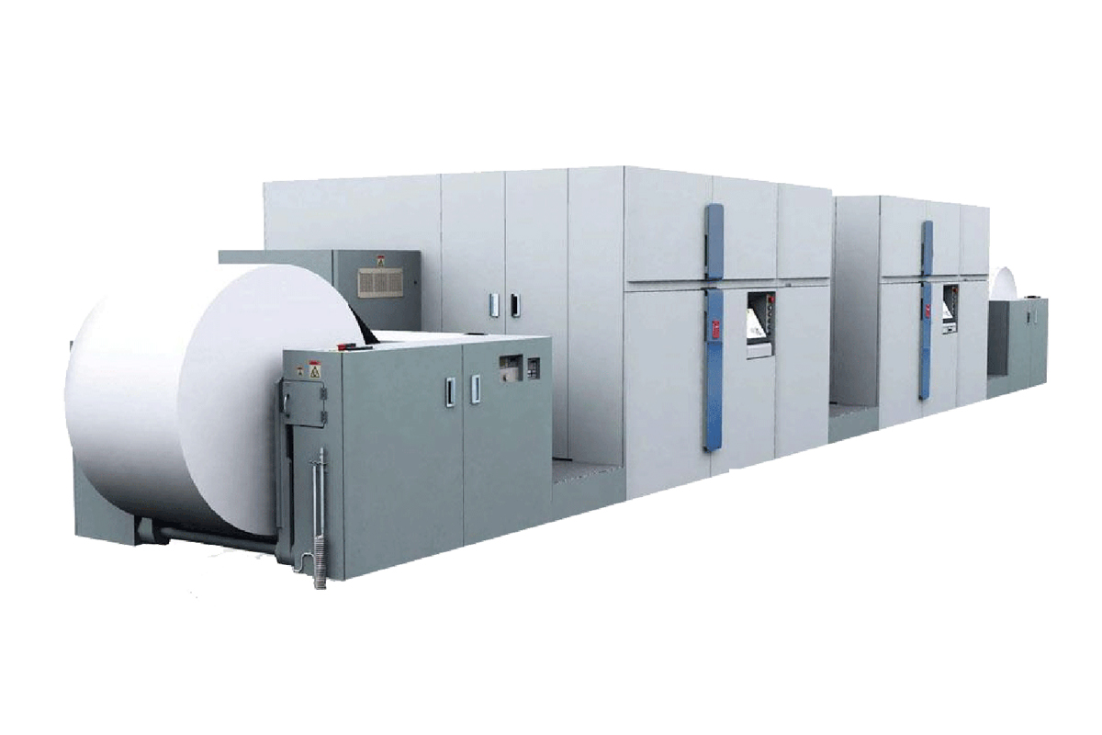
Speed Reported | 163,560 sheets/hr.
FPM Reported | 833
IPM Reported | 5452
Duty Cycle Reported | 165 million letter impressions per month

Digital Front End
Controller Options | SRA MP
Print Streams | IPDS, PCL

Imaging System
Ink Type | Aqueous Dye
Ink Description | Water-based dye, MICR, Security Inks, InkSafe technology
Ink Options | CMYK+ MICR or 1 Spot
Bonding Agent | Not Reported
Primer/Precoat | Not Reported
Drying Methods | heated drum
Head Technology | Piezoelectric Drop-on-Demand
Head Manufacturer | Kyocera
Heads Per Engine | 112
Colors | 5
Droplet Size | 5-12 (variable)
Gray levels | 4
Resolutions | 600x480

Paper & Media
Paper Feed | Roll
Paper Output | Roll
Minimum Web Width | 8.5 in / 216 mm
Maximum Web Width | 30 in / 762 mm
Maximum Print Width Simplex | 29.5 in / 749 mm
Maximum Print Width Duplex | 29.5 in / 749 mm
Minimum Thickness | 64 GSM
Maximum Thickness | 157 GSM
Paper Types | Laser, inkjet treated/coated, recycled, book, newspaper
Specialty Media | Pre-printed, pre-punched, pre-perforated

Market Segments
Manufacturer Segment Notes | Transactional, documents, direct mail and short run books
Applications Segments | Books – Monochrome  Direct Marketing – Self Mailers  Traditional Transaction Print

Configuration
Layout Configuration | I
Print Engines | 2
Print Sides | Duplex
Power Consumption | 140 kW
Footprint: | 486 in x 122 in x 81.5 in / 12,300 mm x 3100 mm x 2070 mm
Noise: | < 80 dB
Weight: | 41, 888 lb / 19000 kg
Humidity Range: | Optimal range 40–60% RH, limited range 30–80% RH

